Cable Knitting
Jill Singer (jillrenee42@gmail.com)and Lisa Winer (galliana@gmail.com)

What do cables look like?
Essentially they look like ropes (cables). Most commonly, when they appear on sweaters in modern department stores, they look like simple twists or spirals in long columns. They may also appear to be elaborate knots inspired by celtic designs, or diagonal lines creating a latticelike effect. What they almost always have in common is that they "pop out" from the surface of the fabric, and appear most frequently in garments and other items meant to provide warmth, as their structure adds bulk to knit fabric.

How are cables created?
Cables are created by knitting stitches out of order, so that they change positions and cross over each other. This results in the fabric being pinched or layered a little where the cable is created, drawing it in and making it "thicker".
The cable is only created on some rows, anpd the stitches are otherwise left alone on the rows in between. Typically, for cables to really POP out of the fabric, the stitches involved in the cable are all KNIT, while the stitches on either side of them are all PURL. The contrast of the knit cable against the purl background allows the design to really emerge, though there are many cables involving a minture of knit and purl stitches for a variety of effects.
The gauge (how many or how few stitches there are in a fixed size section of knitting) also affects how dramatically the cables stand out. The more firm the fabric (knit more tightly) the more the cables will stick out from the fabric. A looser fabric will result in flatter cables, and they will look softer. A firm fabric is warmer than a looser one, as the space between stitches is smaller, and a fabric with cables added will be warmer yet, as more yarn is scrunched together in the same space.
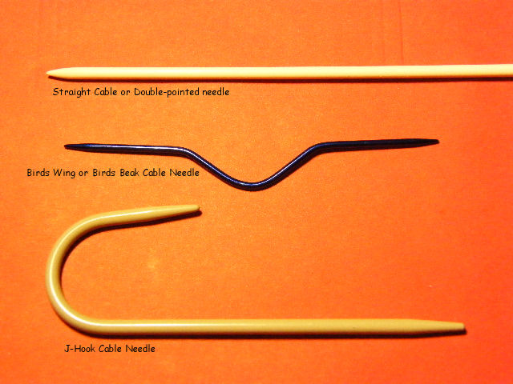
In order to rearrange the stitches to create a cable, a tool called a CABLE NEEDLE can be used. Cable needles come in several common shapes, 1) J or U-shaped 2) Wing type (straight with a curve or indent in the middle) or 3) straight (just like a DPN). All three serve the same purpose, temporarily storing stitches so that you can skip them, knit the next few stitches, and go back to them later.
Regardless of what type of cable needle you prefer, the needle must be no larger in diameter than the size needle you are working with, or the stitches won't fit or will become stretched. http://impeccableknits.wordpress.com/cable-knitting-resources/

LEFT or FRONT cable
In a left twisting cable, the stitches placed on the cable needle are stored in front of the work while the stitches after them are knit first. This way, when the stitches stored on the cable needle are knit and the fabric is puckered, it looks like the stitches are leaning up and to the left.
This type of cable may be referred to as either a LEFT (leans up to the left) or FRONT (stitches are stored in the front of the work) cable.
RIGHT or BACK cable
In a right twisting cable, the stitches placed on the cable needle are stored in the back of the work while the stitches after them are knit first. This way, when the stitches stored on the cable needle are knit and the fabric is puckered, it looks like the stitches are leaning up and to the right.
This type of cable may be referred to as either a RIGHT (leans up to the right) or BACK (stitches are stored i the back of the work) cable.
Does it matter what type of fiber is used for creating cables?
Yes! The choice of fiber, as well as way the yarn is spun, will affect the look of your cable.
Regardless of fiber, the way the yarn itself is spun is important. A more tightly/firmly spun yarn will make a firmer cable because it doesn't get squished down so much when knit as a fluffier yarn.
Wool - In general, wool from sheep makes the springiest, cushiest cables. Wool fibers have "crimp", little kinks, and the more kinks, the springier it is. Think about straight vs curlier hair. Wool also tends to shrink back into shape if it is properly washed and dried.
Also, some wool will make boucier cables than other woo. Merino is lovely and soft, but it is not as kinky ;) as wool from other sheep that is coarser but also curlier.
Pretty much any fiber can be blended with wool, and this can provide a bit of stretch to fibers that normally aren't stretchy and can imporive the appearance of cables.
Cashmere - like wool, cashmere makes nice cables. It is a more delicate fiber than most wools, and commercially available cashmere may be spun softly, because it tends to be used for soft luxury items rather than hard-wearing sweates. It's pretty warm regardless.
Other fibers like, alpaca, silk or cotton can also be used to make cables, but they may not be as bouncy, or may flatten out over time.
Alpaca - tends to have a halo (fluffy bits) that can disguise detailed stitches (not just cables) and tends to stretch over time. It generally does not un-stretch.Alpaca tends to be more drapey than bouncy.
Silk - can make lovely cables, especially when blended with wool. Silk tends to be mostly drapey on its on and not very elastic.
Cotton - cables look fine but cotton is kind of flat and doesn't have much strech, so the cables don't really POP. Cotton is notorious for stretching. Fortunately, cotton can be washed and dried using heat, which may help shrink the fabric back into shape, but it will never be bouncy.
Rayon, tencel - Man-made fibers similar in look and feel to silk.
Bamboo - almost all commercially available bamboo is actually rayon, it's pretty far removed from the bamboo plant.
Acrylic - Cheap and ubiquitous and comes in a HUGE variety of textures. The strechier/bouncier the acrylic feels, the boucier the cables worked from it will be. Red Heart super saver, while not terrible soft to the touch, will make nice, firm cables, while Caron Simply Soft, which is smooth and limp feeling, will make flat, smooth cables that may not really stand out. It is also important to not apply extreme heat directly to acrylic fibers, as the heat can damage (melt) the fibers. Acrylic is, after all, plastic.

Resources
BOOKS
Aran Knitting by Alice Starmore 2010 Edition Dover Publicaions Inc. Mineola, NY
Detailed and often complex cables. Patterns included int he book are mostly for sweaters designed to warm and weather resistant.
The Natural Knitter - How to choose, use, and knit natural fibers from alpaca to yak by Barbara Albright
Websites
Techknitter http://techknitting.blogspot.com/
All sorts of topics on the structure and technique of knittingYarn Harlot - www.yarnharlot.caNumerous stores both related and completely unrelated to knitting. Stephanie Pearl MacPhee is a well known knitter and author of knitting-related books.
Yarn Harlot http://www.yarnharlot.ca/
The Yarn Harlot, AKA Stephanie Pearl-McPhee, is a well known knitter and author of knitting-related books. She is both informative and highly mausing.
http://www.yarnharlot.ca/2006/06/all_is_not_lost/ - An excellent, informative, and entertaining demonstration by the Yarn Harlot on how to repair an incorrectly crossed cable.
Free Pattern Examples
Ravelry - minors 12 and older may hold accounts with Parental supervision. This is an excellent resource, please be responsible when using it. Red Heart, Lion Brand, Patons, Bernat - these are large companies that also have extensive libraries of free patterns on their websites. May require an account to access patterns but all accounts are free. As with Ravelry, age restrictions may apply.
Afghan block depicting Owls. Cables are used to create the owls.
http://www.ravelry.com/patterns/library/waffling-owls-afghan-12-block-or-dishcloth
A hat based on a hat worn by Hermione in one of the Harry Potter movies
http://www.ravelry.com/patterns/library/hermiones-cable--eyelet-hat
Twin Cables Wristers
http://www.redheart.com/free-patterns/twin-cables-wristers
Chunky Cable Cowl (bernat)
http://www.yarnspirations.com/patterns/chunky-cable-cowl.html

Sample cable swatch
The sample cable swatch includes 3 simple cables for practice. A RIGHT spiral, a LEFT spiral, and a BRAID combining the two spiral techniques.
Provided for the practice cables is both a pictorial chart of the stitches, and written out directions. The practice swatch is knit flat, so you will be looking at the front side half the time and the back side the other half of the time.
When using a chart for knitting, the most common type of chart will show ONLY THE FRONT of the work. This means that regardless of whether you are knitting flat or in a circle, the chart shows what the stitch looks like FROM THE FRONT ONLY, so if you are knitting on the reverse side and the chart says to KNIT, this means from the front it looks like a KNIT and on the back you PURL. A good pattern designer will give you clear directions on what each symbol means and what to do if you are looking at the front or the back when you get there.
The rows will be numbered. Some charts will show every row, and some will only show every other row, if nothing special is happening on the "even" or "return" rows. The chart for this cable sample includes EVERY ROW. For an item knit FLAT (back and forth) when looking at the front of your work you read the chart from right to left, and when looking at the back of your work you read the chart from left to right.
When following WRITTEN directions, you should follow them exactly as written. If the directions say to purl, then purl.
K - knit
P - purl
CL2 - 4 stitch cable leaning to the left. Slip 2 stitches onto the cable needle and hold in FRONT of the work. Knit following 2 stitches, then Knit the two stitches from the cable needle.
CR2 - 4 stitch cable leaning to the right. Slip 2 stitches onto the cable needle and hold in BACK of the work. Knit following 2 stitches, then Knit the two stitches from the cable needle.
Note: When on the back of the cables (the “even” rows); knit the knits and purl the purls.
Knit stitches have “scarves” around them; while purls have a bump or a “noose”.
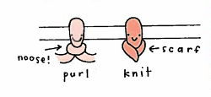 ( from Stitch ‘N Bitch by Debbie Stoller)
DIRECTIONS: CAST ON 36 STITCHES
Knit four rows of garter stitch
Knit rows 1 through 8. This produces 3 columns of cables, one twisting to the right, one twisting to the left, and one that creates a braid. 8 rows complete one section of braid. Repeat Rows 1-8 until you are get either six inches, the cables look good, or you sick of it; then knit 4 rows of garter, and bind off.
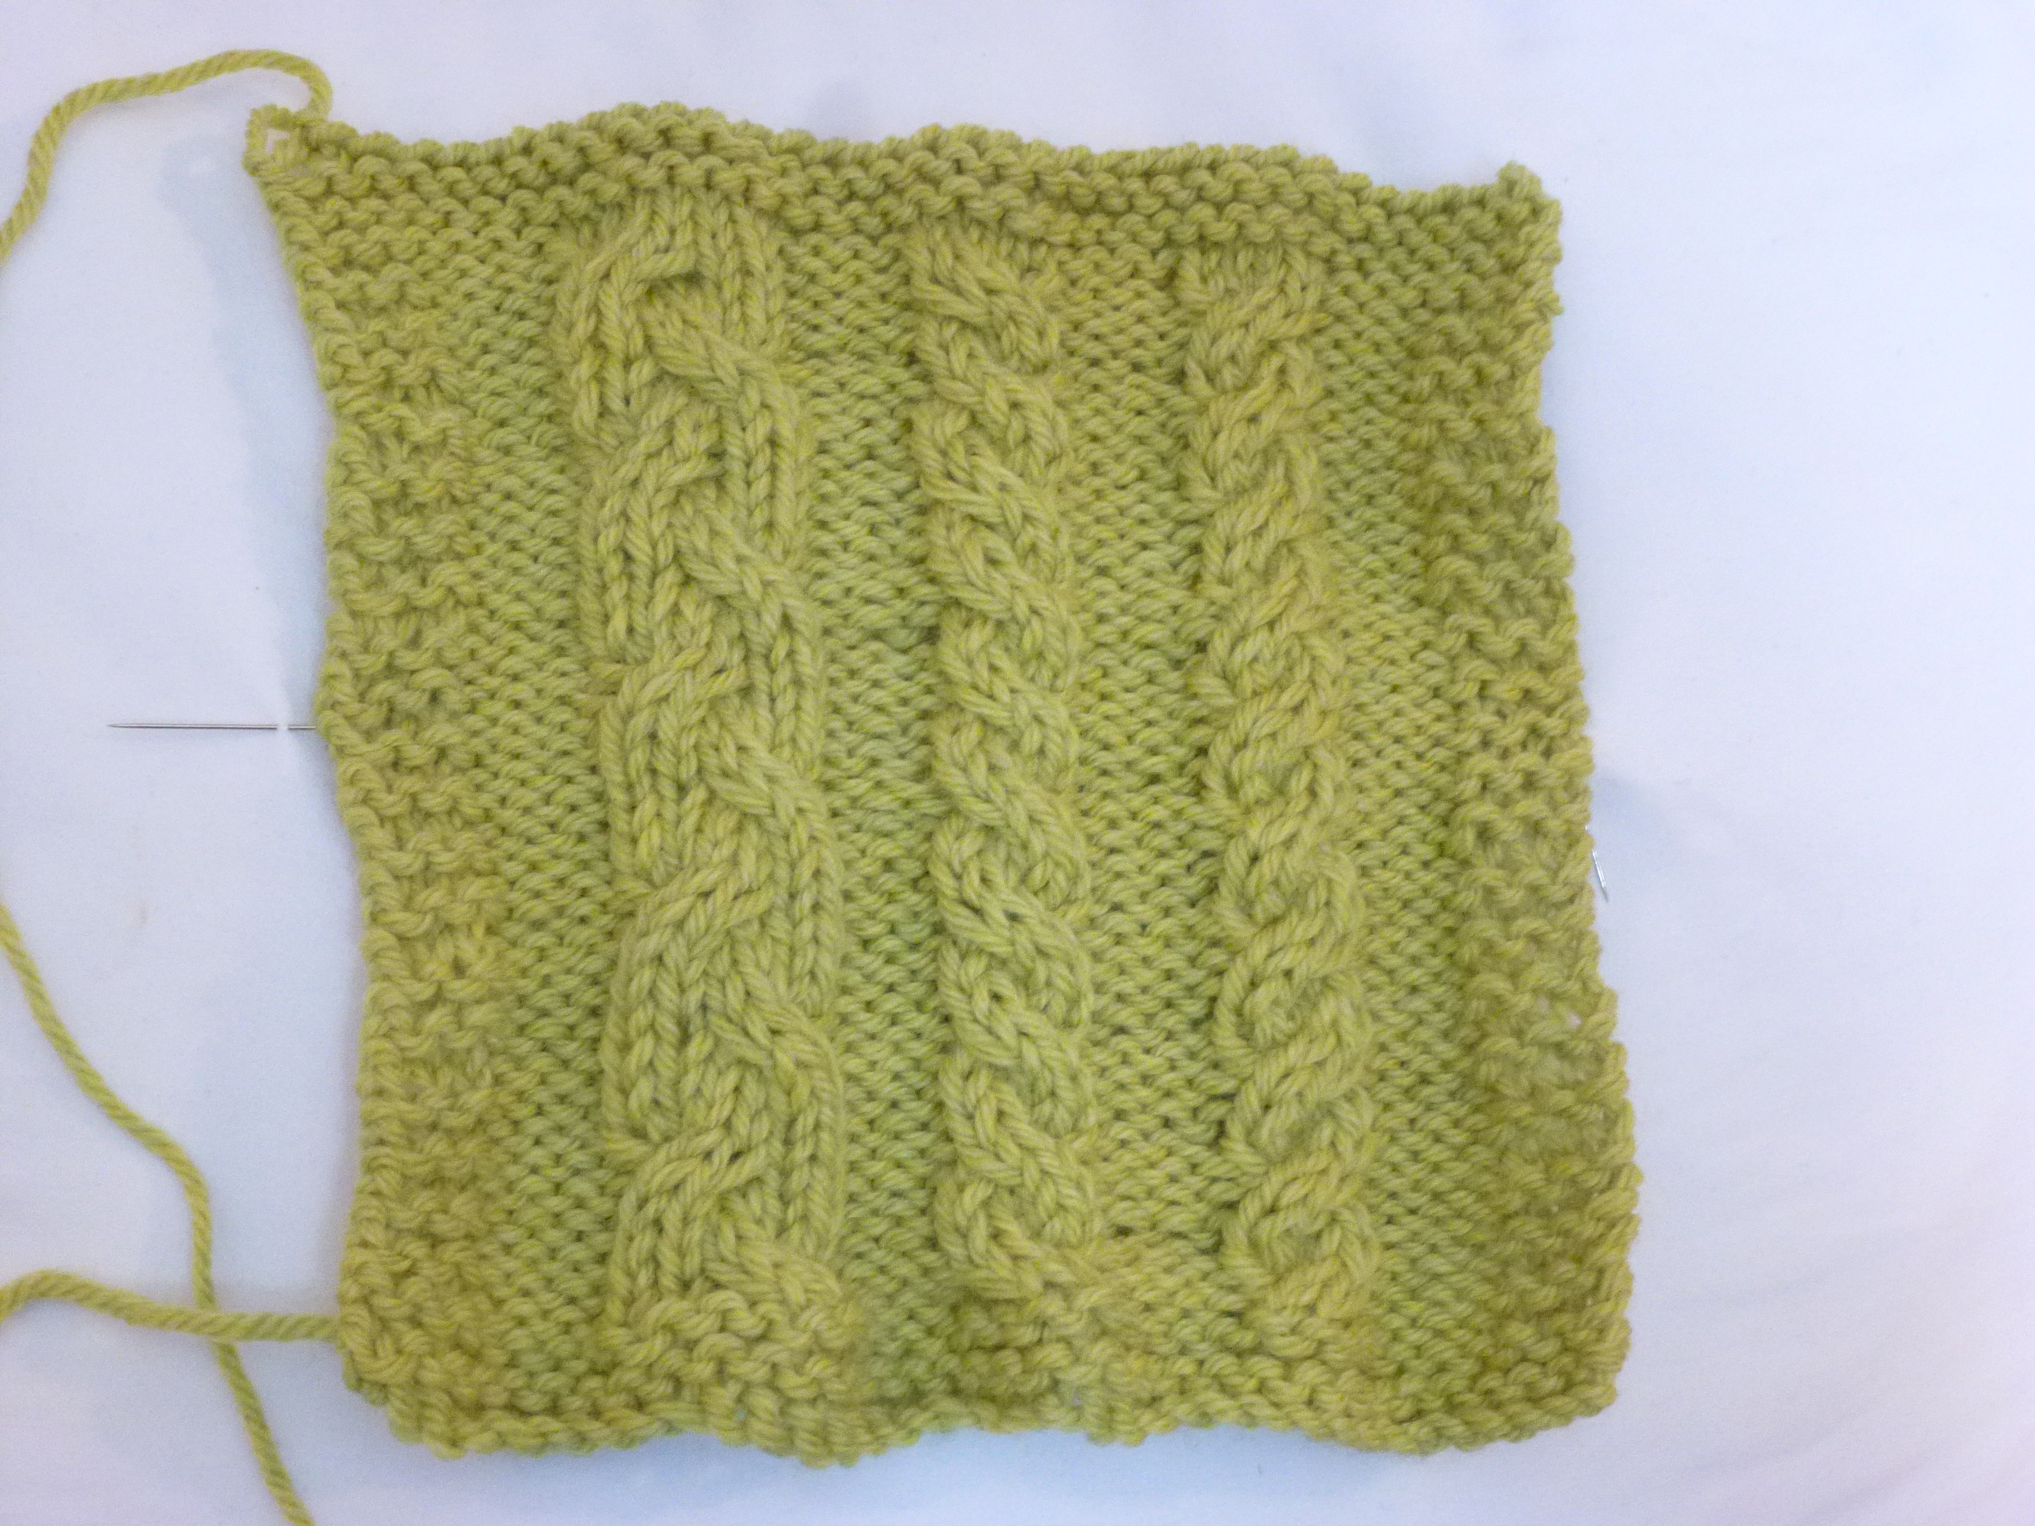
ROW 1 K3, P4, K4, P4, P4, K6, P4, K3
ROW 2 K3, K4, P6, K4, P4, K4, P4, K4, K3
ROW 3 K3, P4, CR2, P4, CL2, P4, CL2, K2, P4, K3
ROW 4 K3, K4, P6, K4, P4, K4, P4, K4, K3
ROW 5 K3, P4, K4, P4, P4, K6, P4, K3
ROW 6 K3, K4, P6, K4, P4, K4, P4, K4, K3
ROW 7 K3, P4, CR2, P4, CL2, P4, K2, CR2, P4, K3
ROW 8 K3, K4, P6, K4, P4, K4
